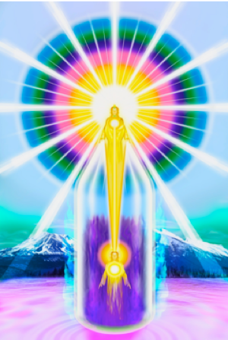
THE MAGIC “I AM” PRESENCE

“I AM” WORKSHOP
FREE, ON-LINE 12-WEEK INTRODUCTORY COURSE
DATES: 27th MAY to 12TH AUGUST 2020
NEW ZOOM LINK TO BE SENT OUT WEEKLY

WEBSITE: https://iamfree.co.za/
YOUTUBE: https://www.youtube.com/channel/UCoWIqDA6jimykgCpav4HToA/videos
MEETING TIME: South African time - 7pm - 8.15pm
USA Pacific Standard Time (PST) 10am – 11.15am (daylight saving adjustments need to be watched)
India – Delhi 10.30pm – 11.45pm
If your times is not mentioned, you will need to get a time converter.

IMPORTANT NOTES:
- All information is from the Ascended Masters according to the “I AM” Activity & The Bridge to Freedom material, this includes ADK Luk books.

- There will often be readings directly from the books during the sessions. The words of the Ascended Masters carry a radiation, that human words don’t carry.

- Each week a document will be sent to attendees via email covering the material we will study for the week. It will also give suggested ‘homework’ to be done prior to the weekly session. I will send this out a week in advance, and to progress it will be important to study the suggested material.

- Each session will be recorded, to re-listen or for missed sessions.

- There will be ±10 minutes allowed at the end of the session for questions & suggestions. This is for questions related specifically to the topics covered, and also spending a little time communicating with other members of the group.

- All sessions will start and finish with a few quiet moments connecting with our “I AM” Presence and invoking the Ascended Masters to Guide and Protect us through the session. A short Decree session will be added after week five.

WEEK ONE
Introduction
  - Using Zoom
  - Meeting each other
  - Brief explanation of the intention of the Course
  - How the Teachings came in and the 2 Major Dispensations

WEEK TWO
- Brief history of the Earth & the ‘fall of man’ - The Supreme importance of the hour
- The Current Cycle and Cosmic In-breath
- The Divine Plan
- The Ascended Masters and who They are
- Saint Germain
- Sanat Kumara
- The Karmic Board and Hierarchy in the Heavenly Realms

WEEK THREE
- The “I AM” Presence
- Description of the Chart (Drawing of the Chart)
- The Power of the words “I AM” – the ‘Name’ of God
- Readings on the Power of our “I AM” Presence

WEEK FOUR
- The Tube of Light – essential Protection
- The Violet Fire – The redemption of the world, and the predominant Ray

WEEK FIVE
- The Scepter & The Crown
- Remedies
- Meditation
- Decreeing

WEEK SIX
- The Laws of Life
- The Law of Harmony
- The Seven Rays
- The Power of the Light – Cosmic Light

WEEK SEVEN
- The Elemental Kingdom
- Consciously working with the Elemental – decreeing for their purification

WEEK EIGHT
- The Angelic Kingdom
- Co-creating Heaven on Earth again – Saint Germain

WEEK NINE
- The Rhythmic Breath & The Retreats of the Ascended Masters

WEEK TEN
- Group work
- The Transmission Flame service

WEEK ELEVEN
- Energy & vibration and the things the Ascended Masters suggest we avoid in the physical world
- Chakras in the New Age - Return to the original chakra colours & their function
- Colours

WEEK TWELVE
- The Ascension – our next step on the evolutionary path
- Closing Discussion

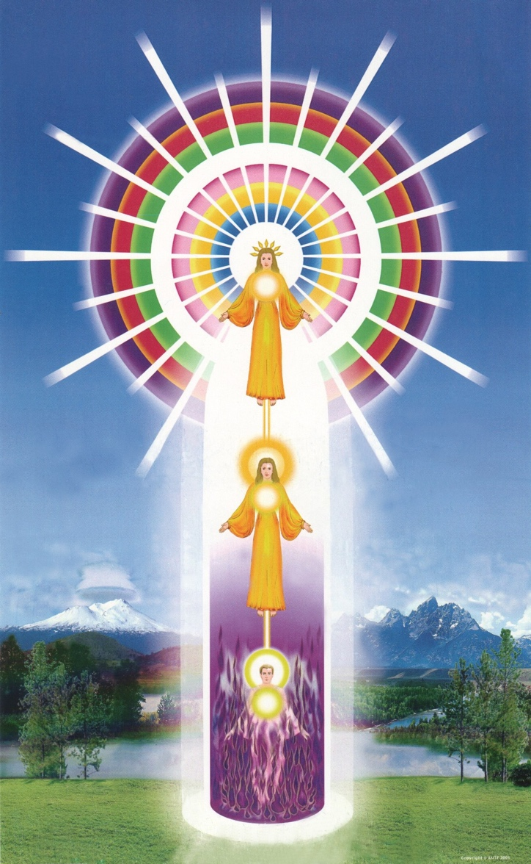
CHART OF THE MAGIC “I AM” PRESENCE
(Image courtesy AMTF – Mt Shasta)
Here the colours in the Causal Body are in the correct order and the Holy Christ Self is included. This information on the order of the Rays in our Causal Bodies, was given to Geraldine Innocente and the Philadelphia Group in the 1950’s

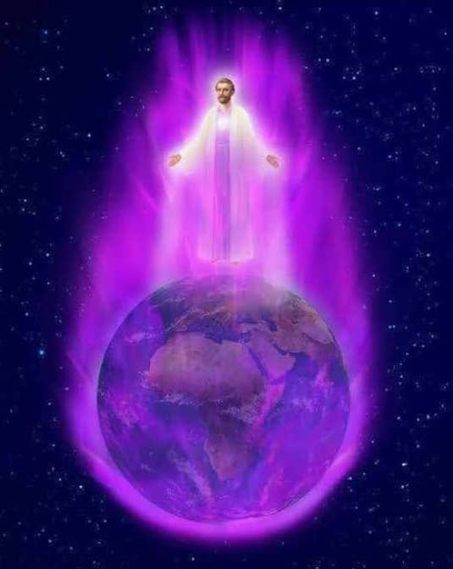
BELOVED SAINT GERMAIN AND THE VIOLET FLAME

