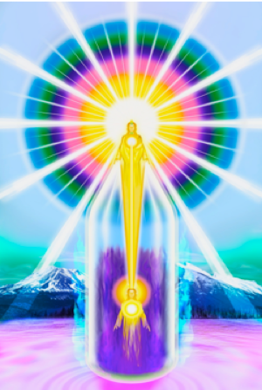
THE MAGIC “I AM” PRESENCE

THE 7 RAYS
FREE, ON-LINE 7-WEEK WORKSHOP
DATES: 25th MAY to 6th JULY 2020
NEW ZOOM LINK TO BE SENT OUT WEEKLY

WEBSITE: https://iamfree.co.za/
YOUTUBE: https://www.youtube.com/channel/UCoWIqDA6jimykgCpav4HToA/videos
MEETING TIME: South African time - 7pm - 8.15pm
USA Pacific Standard Time (PST) 10am – 11.15am (daylight saving adjustments)
India – Delhi 10.30pm – 11.45pm
If your times is not mentioned, you will need to get a time converter.

IMPORTANT NOTES:
- All information is from the Ascended Masters according to the “I AM” Activity & The Bridge to Freedom material, this includes ADK Luk books.

- There will often be readings directly from the books during the sessions. The words of the Ascended Masters carry a radiation, that human words don’t carry.

- Each week a document will be sent to attendees via email covering the material we will study for the week. It will also give suggested ‘homework’ to be done prior to the weekly session. I will send this out a week in advance, and to progress it will be important to study the suggested material.

- Each session will be recorded, to re-listen or for missed sessions.

- There will be ±10 minutes allowed at the end of the session for questions. This is for questions related specifically to the topics covered and group discussions.

- All sessions will start and finish with a few quiet moments connecting with our “I AM” Presence and invoking the Ascended Masters to Guide and Protect us through the session, and there will be a short ‘Decree Service’ at the beginning of each meeting.

WEEK ONE
The First Ray – Blue - The Will of God, Power, Protection & Faith

WEEK TWO
The Second Ray – Golden-Yellow – Illumination, Wisdom, Discernment & Discrimination

WEEK THREE
The Third Ray – Pink - Pure Divine Unconditional Love

WEEK FOUR
The Fourth Ray – Pure White – Purity & Ascension

WEEK FIVE
The Fifth Ray – Emerald Green – Truth, Healing, Concentration & Consecration

WEEK SIX
The Sixth Ray – Ruby with a Gold Radiance – Peace & Ministration

WEEK SEVEN
The Seventh Ray - Violet – Mercy, Forgiveness, Transmutation, Invocation, Rhythm and Ceremony

Each week we will cover material given to us by the Ascended Masters on the:

- The Virtues & Qualities of the Ray
- The Divine Beings ministering to the Ray
- Our Use of the Ray
- Initiations of the Rays

BELOVED SAINT GERMAIN, CHOHAN OF THE 7TH RAY

