THE WORDS “I AM”

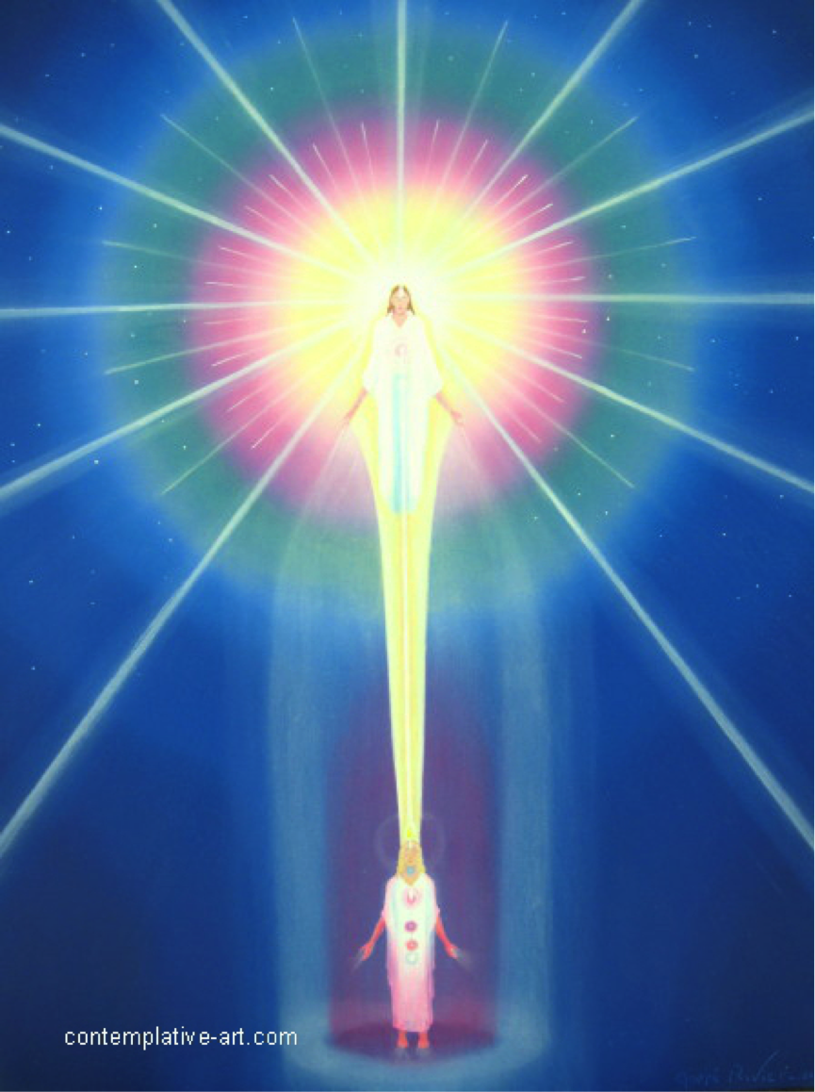

"The Words, "I AM," as written in English today, have come down from the Beginning of mankind's appearance upon the Earth. In the Royal Teton—on your map, known as the Grand Teton, there are the Records of these civilizations—every one which has ever been on Earth. In every language which was used during those many civilizations—the Words, "I AM" as written in English today are there; showing Those Two Words are the Power of God.

Mankind needs to learn to use Those Words, as We do. In any crisis, if the Individual did not think of anything else just for the moment, and would say: "I AM," "I AM," "I AM," It would release the Powers of the Presence into action! Ofttimes it would perform a so-called Miracle for him or her, then and there! That is the Power of those Two Words; and there are no two words in the vocabulary of human experience, which release the Power Those Two Words do. The Words, "God," "Divine Mind," "Divinity" and all other Terminology used to express the Godhead, do not contain the Power the Words "I AM" do. That is the Reason why Beloved Saint Germain has brought This Use of the "I AM" forth to mankind at this time. It is the Power which sets the people Free! Why? Because It is their own Life!
Your "Mighty I AM Presence," your Individualized Presence of God which beats your Heart, is your Life; and your Life contains everything which is for your Perfection."

The Great Divine Director "I AM" Discourses - Book 8

Excerpt from: LAW OF LIFE – ADK LUK - Page 65

Amen is a form of the Word “I AM.”

AUM – OM is “AM,” the negative or feminine aspect of “I AM,” the action of which is All.

Under the occult or old law, this was all that was permitted to be given. “I” is the individualizing action, thus “I AM” is the positive or masculine aspect. In the new cycle the knowledge of the full action is permitted, and the new Teaching is the combination of the masculine and feminine aspects, the use of the full name of God. Jesus gave the Lord’s Prayer for the masses who did not understand the Law, know of the Sacred Fire or know their I AM Presence as He did.

No matter what religion or faith an individual believes in or what metaphysical or occult teachings he may be following, they all eventually lead to the same vital and focal principle
- the knowledge and awareness of the I AM Presence. No one gets into the higher realms and cosmic development except through his own Individualized I AM Presence.

The unascended masters in India have touched on this principle. They have contact with their I AM Presence, although they may call It by another name. They would not reveal this fact or even speak of it in those terms, but they have made the inner contact and are aware of their own Presence.
The I AM Presence is the all-pervading principle in life, the most divine activity in the universe. It is the only active principle each one has. It is ever striving for expression to produce perfection through each form.
The first principle of life is to love. That is the nature of every individual. Love is the fundamental principle of all creation.
“I AM” is the life principle and intelligence in your body. It is the principle of life expressed through Jesus. Real intelligence is not an activity of the intellect, but comes from the God-Principle, the Flame – ”I AM”, and uses everything constructively.
The three principles, faith, hope, and charity (love) are always active in mankind.

“I AM” is the creative word, the initial word that produced creation and from which all creation springs. The words “I AM” are the cup – the two cups that carry the power into outer activity. The use of the word “I AM” denotes individualized being.
The word “I AM” as spoken in English releases the energy from God, your own Individualized Presence, which is your Source. That Presence is the fountain of energy from which you receive, every moment of your life, the energy that keeps you alive. When you say the words “I AM” then you invoke life. To think or speak those words draws life into manifestation.
Have you ever thought that you use “I AM” preceding all you do in your daily activities, either in thought, feeling or spoken word and that no other person can say or use that expression for you? On awakening in the morning you think or say before you get up “I AM going to get up”. “I AM going to get breakfast”. “I AM going to work” and so on. In everything you do you use the expression “I AM”. When used, it draws forth and releases more, or added, energy into your world to perform the act you desire.
The expression “I AM” as used in English has ever been used all through the ages from the beginning of the world. Although that secret knowledge was lost to the masses, it has always been known and used in the Retreats. Jesus said death and life are in the power of the tongue, meaning the use of the word “I AM”, and if you will notice, He preceded His important statements with the word “I AM”. Most people are familiar with these statements:
I AM the light of the world; I AM the light that lighteth every man; I AM the resurrection and the life; I AM the ascension in the light; I AM that I AM. Also, the light of the body is the eye (I AM), if your eye be single (meaning your inner ‘third eye) your body will be filled with light. These statements have lived through the centuries and remained unaltered, they could not be changed. They still carry the same meaning and potency. “I AM” is the so-called “lost word”. The word itself was not lost but the inner or real meaning, understanding, use and power, were lost to the consciousness of mankind. When you use I (or a form of it as me, my, mine) never use a negative word following it.
Life is the ALL and says “I” to denote individualization. An individual says “I”. Sight is the same frequency as “I” – eye. “I” is when light looks within itself, that is the attribute of sight – the eye, the same as “I” when it individualizes itself. When you say “I AM” that is the first announcing. A new born baby’s first cry or sound means “I AM”, announcing its individual identity here in the physical realm. Birds and animals do not use or say “I AM”, because they are not endowed with the power to say “I AM”.
The word “I AM” is recorded in the Grand Teton Retreat, in every language of ever because they are not endowed with the power to say “I AM”.
The word “I AM” is recorded in the Grand Teton Retreat, in every language of every civilization that has been on the Earth.
The sound “I AM” is the same tone as used in the first Golden Ages.

The Magic Presence “I AM”
The physical form – you, your outer self, is at the bottom. Above or over that is the Individualized Presence of God – the Magic I AM Presence, your Source. It is in a body of Light substance. If you were to see It, It would appear in a form similar to the physical body, but vibrating at a much higher rate, therefore It is not visible to the physical sight. It is a living Being, intelligent, real, in blazing light. It is a focus of all the God powers that your outer self may draw upon. It supplies the outer self with life, intelligence, power, and action. Man enjoys all Its powers but does not understand it. You can speak to It as you speak to a friend. Jesus called It the “Father”.
Rays of intense white light pour out from the Presence, some large and many smaller ones.
Around the Presence are spheres of light substance in colors of the seven rays, and the
various tints of each ray. In the center is the white light, the natural radiance of the Presence. Outside of that is a sphere of electric blue. (On a flat surface they are portrayed as circles or bands of colors, but are in reality spheres.) Outside and around the blue is one of yellow. Then around it a beautiful pink, around that crystal white, next is an apple green, then the ruby (or this may be gold), and the outer sphere is violet or purple. These are in order of the seven rays, and they inter-blend. That is known as the Causal Body which contains all the accumulated good – the constructively qualified essence of that lifestream through the ages, created both while in embodiment and between embodiments. These spheres vary with each individual in size and quality.
White rays from the I AM Presence pour out through these spheres of colors, utilizing the qualities there in Its Cosmic action. They are the action of Divine mind and love by which the Presence carries on Its creation at Cosmic levels.
From the heart of the Presence is a ray of light extending down, entering the human body through the top of the head (where the soft spot is in a newborn child), and it is anchored in the heart. This is the stream of life that beats the heart and keeps the person alive. When it withdraws, so-called death ensues. In like manner, the Presence is connected by a ray of light with the Central Sun through the Sun of the system. The ray of light from the Presence (Silver Cord) enters the top of the head, goes to the heart, and to the base of the brain (the medulla oblongata), and from there is distributed by tiny threads of light to every cell of the body. This is how your body has life. This is an unconscious action on the part of the outer self but consciously carried on by the Christ Self (Higher Mental Body) and Body Elemental; there being distributed enough light for the body to function properly in the physical to render the services in the outer that the Christ Self wants to do in that embodiment and fulfill the divine plan. In mankind today much of the energy is drawn down by the outer self and used discordantly in the various human expressions, but it should be poured back in love to the Magic I AM Presence, thus completing the circuit. That is the right action.
Around the human form is a Pillar of Light. It is established, or placed there, by the Magic I AM Presence, at the call of the outer or personal self. This Pillar of protection insulates the lower bodies from the vibratory action in which one must move. Within the Pillar of Light can be established the Transmuting Violet Flame of Divine love, mercy and compassion. This also is done at the call of the personal self, and can be activated at any time to any degree, depending on the capacity of the individual. This is how one can redeem karma – the destructively qualified energy of all lives, all misuse of energy of the lifestream as well as that accepted from without. This accumulation is condensed around the physical form. In between embodiments this accumulation stays in the atmosphere of Earth while the individual sojourns into the realms of light. At re-embodiment most of it is held in abeyance until around the fourteenth year, when it is returned to the individual, its creator. The Pillar of Light and Violet Flame interpenetrate each other.

THE CHRIST SELF
Above the physical body is the Christ Self (Higher Mental Body), called the Higher Self, It is also known as the Guardian Angel. It abides between the Presence and the outer, or human form (usually not illustrated). It has been provided by the Presence to act for and take care of the requirements of the outer self. It is the only begotten Son of God. The Christ Self is the action of the Presence that knows Its perfection and also knows the imperfections and requirements of the outer self. It is endowed with the discriminating intelligence to act in the outer. It might be termed a step-down transformer with the capacity to act in the lower realms. The Christ Self does not accept any imperfection of the outer but remains wholly pure and perfect. It is an intelligent Being in a body of light, has form but of a lower vibratory rate than that of the Presence. It is the vehicle through which the Presence acts in the physical realm. Therefore when you call to your Presence, in reality the Christ Self performs the service. The bodies of the Presence and Christ Self are just as tangible in their own realms of vibratory action as the physical body is here to the physical senses.
The diagram represents your own Individualized Presence of God, “I AM”, in Its relationship to you. A picture is an outpost of what it represents. A picture is the greatest focus of any Divine Being or inner activity in the outer world. The diagram or chart is the only explanation of the truth of this law. It is an eye picture of the release of the power of the universe which knows no opposite. The knowledge and understanding of the Presence and Its action is your freedom. The diagram (chart) shows the trinity of your faculties acting at one point. It is a trinity of action. It is the action of the Three-fold Flame. In every activity in the universe there is a trinity of action – love, wisdom and power which in the knowledge of the Presence becomes one. The chart is only an outer picture of It. One needs, then, to make effort for the realization of It. That is what these teachings are trying to do, to realize God. Contemplate the Presence – the chart at night. Keep feeling, feeling It is your powerhouse. One can hold a steady gaze upon the upper figure until a funnel of light forms between you and It, especially on a colored chart. Most important is your knowledge, understanding and acceptance of your Individualized I AM Presence in relationship to yourself as represented on the chart.
Even an individual who is doubtful, if he were to look at the chart sincerely, wanting to know, for five minutes each day, he would get his proof.

The I AM Presence
When you call to the Presence, you are calling to the Presence of everyone in the world. Even earnest students do not realize what a power their call to the Presence is.
Contemplate life. Where does it come from? From the Magic I AM Presence. Without that life, light, energy, flowing into you from the Presence you would have no intelligence, thought, feeling or action. Therefore you can see that it is the action of the Presence of God.
The Presence is the doer in every way. So as to make the outer self accept the fact you can say to your Presence: “It is my Magic I AM Presence making this call; it is the Presence acting and also answering it”.
Because mankind have turned away from the light, (although there is the connection with their Presence through the ray or stream of light into the heart), each one must now again make a conscious connection with his Source, make contact with his own God Presence anchored in his heart. To go on into greater expansion and cosmic activities it is one’s own
I AM Presence he will progress in or through. No one can get away from that no matter what the teaching is.
DAILY APPLICATION
Each day, hold the attention definitely and unwaveringly on the Presence even if just for a short time.
Try to realize when contemplating the Presence, that in It are the powers of the universe, given to you as a gift of Divine love.
Attention to the Presence is the most powerful thing in the universe, but the attention must be held unwavering for a time. Knowing the Presence you now have a point of focus on which to anchor your attention.
Give attention to and become acquainted with your own Individualized Presence of God THE MAGIC I AM PRESENCE.
Since we of our own free will have turned away from the Presence of God, It will not act in our world except by invitation. As you give attention to and call to your Presence It will expand more and more through you. And as less attention is given to discord and the Presence expands and increases Its light in you, the shadows and limitations will decrease.
Your consciousness determines the distance of the Presence. Its closeness is according to your thought and feeling. It is not a matter of distance according to the human sense of space. In cosmic reality the Presence abides in a certain realm of light. If the Presence and Causal Body abide in the atmosphere of Earth, how could any discord or imperfection be here? The Presence in actuality is not in Earth’s atmosphere. It is a Being of a four dimensional, and even higher dimensional action, but of course in radiance It can be as great and as close as you accept It. It was said that if the Christ Self came as close as three feet to the outer self, the latter would become blazing light.
The Presence is constantly active at cosmic levels. The energy in the Causal Body is not stagnant. The Presence directs light rays through It and utilizes the accumulated good in cosmic creation. The Presence knows not of the human creation of the outerself, but the Christ Self does. When one is purified and harmonized sufficiently, the accumulated good in the Causal Body is released into one’s outer use.
The Three-fold Flame in the heart is a projection of the Presence, but the greater part is above. More and more of that Presence can be drawn forth and made manifest through the physical form. Even where the Presence is portrayed close to the physical body it is still without. The need is to get more of It in action through the physical body and that is done through consciousness and not through a concept of form in three dimensional activity.
The Three-fold Flame in the heart of undeveloped mankind is only a spark. In an advanced student it becomes a little replica of the Presence, which is in some teachings referred to as the “Golden Man in the heart”.
Other teachings have a more abstract idea as to God and law, while this new instruction explains God as an Individualized Presence within and above and to which the physical form or body is connected. It gives one a sense of something more concrete. Most people have a concept of God as an abstract principle only, instead of a focused Presence, an Individualized living Being – a Being to Whom you can talk and Who hears and answers your prayers or calls. Contemplate your Presence, try to get a feeling of Its reality – a living, all-wise Being. Pour your love to It, and it is possible to feel a response from It. Some people think they cannot love a Being unseen to them, or not present to their physical touch, yet when one thinks it through he can generate a feeling of love when he thinks of a child or person he loves very, very much. In that same way one can pour love to his own God Presence, Who has been ignored and forgotten for a very long time, yet through the ages It has kept on giving you life and all by which you have had an existence.
The spheres of color around the Presence represent the powers of the Presence. They are symbolized by blue which represents power and protection; yellow, illumination – the Christ in action; pink, love – divine compassion; white, purity; green, precipitating power – consecration; ruby, the color of the Sixth Ray, (instead of ruby, gold is usually used at this present stage of development, as Jesus the Chohan of the Sixth Ray has been working under the Christ activity), the action of ministration; violet, (the Violet Flame)
transmutation. The action of the Seventh Ray is not only that of transmutation, (on other planets where there is no discord they do not need purification as we do here on Earth) but also of invocation and radiation. The colors of the Causal Body are tentative.
We use one color for each ray although each color is seven-fold, ranging from a very light tint to a very deep color. For example the violet: from a light orchid to a deep purple.
This knowledge of the Individualized Presence gives one a definite focus of God, a power-house and active Intelligence from which to draw. Knowing God just as spirit does not give that. Spirit is the radiance or radiation of the focalized Presence of God. Spirit is the radiation, the aura or Causal Body, but within that is the Individualized Presence. It is said God is spirit, God is love – yes true, but those are only abstract ideas.
Here is a vital and important point in this understanding, not given in other teachings, that our Individualized Presences of God are in heaven (the higher realms), while we as individuals are active in the human realm.
The Presence is the highest activity, individually – the Presence of God Whose thought is flame and Whose desire is creation.
Your Presence is the foundation of the universe, It is one with the Great I AM. Your Presence (the governor of the universe) has projected you – the Light pattern upon which your human form is built, so you see you are a part of that great perfection. Your Presence is individualized, yet It is one with the Great I AM, which is one in quality so we can justly say that all are One.
The mankind of Earth were immortal beings before they came, and not to evolve into immortals, but to expand their light and become greater outposts to render service to the universe. You are outposts of the Presence. You are the focus of the Godhead at your point in the universe.
Acceptance is a power of infinite activity within you. It is the Presence in action. According to your balancing of Its Powers will you have the fullness of the Presence or only part of It. When we call the Presence into action It compels Divine love, wisdom, and power in balanced action. God in action – think what that means! There is only one way – your acknowledgment of the Magic I AM Presence.
The energy flowing through the stream of light, the “Silver Cord” as it is sometimes called, does not discriminate; but when you call to the Presence that becomes a wholly different thing. It is one thing to know the Presence is there, but to have Its action here is the Great Command. That ray of light from the Presence is just energy flowing. When one knows the Presence then in the call to that Presence it becomes love, wisdom and power in balanced action. One who does not know, and accept his or her Magic I AM Presence cannot have that action.
Everything that is in the physical realm has come through the stream of light from the Presence. That energy from your Electronic Body, the I AM Presence, can be requalified. Charge it with Ascended Master consciousness which cannot be requalified. It requires only a sufficient determination for anything, for the Presence to release the power for full manifestation.
Practice accepting the Presence. One must use or practice the Presence. Just to come into the knowledge of the Presence is not enough. Know in your feelings that a ray of light from the Presence beats your heart.
The “Open door” really represents the Presence.

